The data was collected from the National Survey on Drug use and Health(NSDUH) and this study investigated the impact of demographic characteristics and education factors on diabetes disease. The sample size (n) of the data set is 5794. The analysis is done by using SPSS and using frequency distribution and joint frequency distribution.

SPSS Analysis Result:

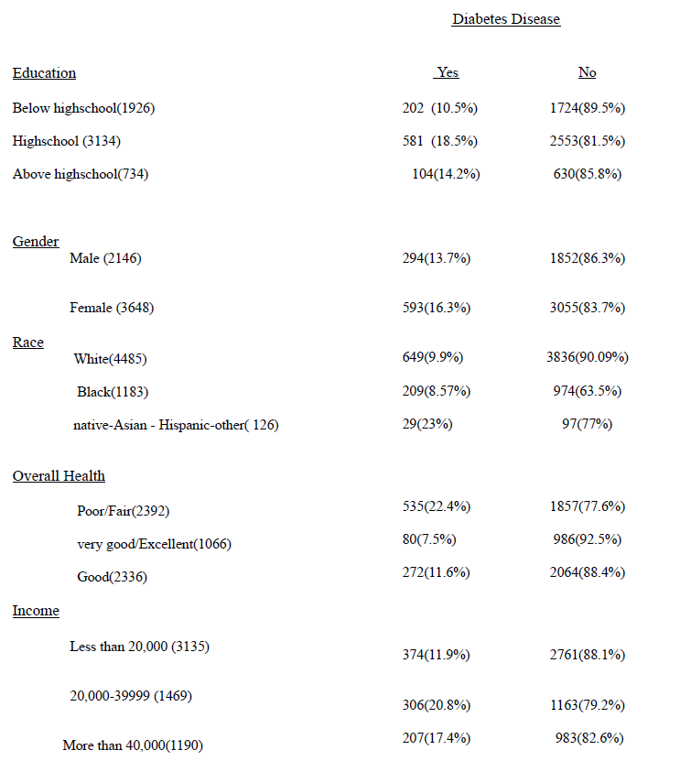

The diabetes disease variable is a category variable where “yes” represents that the person is having diabetes and “no” represents not having diabetes diseases. On the other hand, in this study there are 5 variables, and all are categorical variables.

When we observe the “Education” variable, there were a total of 3134 students who were in a high school, and out of these students 581 have diabetes which is 18.5% and the rest did not have diabetes disease i.e., 2553 (81.5%). Also, the frequency of the below high school and the above high school is 1926 and 734, respectively. Out of 1926 students, 202 students had diabetes which is 10.5% and the rest did not have diabetes disease i.e., 1724 (89.5%). On the other hand, out of 734 students, 104 students had diabetes which is 14.2% and the rest did not have diabetes disease i.e., 630 (85.8%). Thus, the highest diabetes students fall under the “Education” category for “high school”.

After that, we observe the second variable, “Gender”, the frequency of male and female is 2146 and 3648, respectively. So, there were 2146 males, out of 294 (13.7%) who have diabetes and the rest did not have diabetes i.e., 1852 (86.3%). On the other hand, there were 3648 females, out of 593 (16.3%) who have diabetes and the rest did not have diabetes i.e., 3055 (83.7%). Thus, females have the highest diabetes diseases as compared to males.

Thirdly, when we observe the “Race” variable, there were a total of 4485 people who were classed as white, and out of these people 649 have diabetes which is 9.9% and the rest did not have diabetes disease i.e., 3836 (90.9%). Also, the frequency of the black classed people and the native-Asian - Hispanic-other is 1183 and 126, respectively. Out of 1183 black classed people, 209 people had diabetes which is 8.57% and the rest did not have diabetes disease i.e., 947 (63.5%). On the other hand, out of 126 native-Asian - Hispanic-other classed people, 29 people had diabetes which is 23% and the rest did not have diabetes disease i.e., 97 (77%). Thus, the highest diabetes classed people come under the “Race” category for “native-Asian - Hispanic-other”.

Fourthly, when we observe the “Overall Health” variable, there were a total of 1066 people who were classed as Poor/Fair and out of these people 535 have diabetes which is 22.4% and the rest did not have diabetes disease i.e., 1857 (77.6%). In addition, the frequency of very good/Excellent classed people and Good classed people is 1066 and 2336, respectively. Out of 1066 “very good/Excellent” classed people, 80 people had diabetes which is 7.5% and the rest did not have diabetes disease i.e., 986 (92.5%). On the other hand, out of 2336 “Good” classed people, 272 people had diabetes which is 11.6% and the rest did not have diabetes disease i.e., 2064 (88.4%). Thus, the highest diabetes classed people come under the “Overall Health” category for “Poor/Fair”. In general, if people's overall health condition is poor/fair or body weak, then, there are more chances of illness and lifestyle diseases associated with diabetes, stroke, chronic obstructive pulmonary and so forth.

Lastly, when we observe the “Income” variable, it is classified in three groups of income that is less than 20,000, income between 20,000 to 39,999 and more than 40,000. Mostly, individuals fall in the group of income less than 20,000.

There were a total of 3135 people who were classed as less than 20,000, and out of these people 374 have diabetes which is 11.9% and the rest did not have diabetes disease i.e., 2761 (88.1%). Additionally, the frequency of the second income group people and the third income group people is 1469 and 1190, respectively. Out of 1469 in the second income group people, 306 people had diabetes which is 20.8% and the rest did not have diabetes disease i.e., 1163 (79.2%). On the other hand, out of 1190 in the third income group people, 207 people had diabetes which is 17.4% and the rest did not have diabetes disease i.e., 983 (82.6%). Thus, the highest diabetes income group people come under the “second income group” category.